Multiplication table

DESCRIPTION:
Your task, is to create N×N multiplication table, of size provided in parameter.
For example, when given size is 3:

SOLUTION:
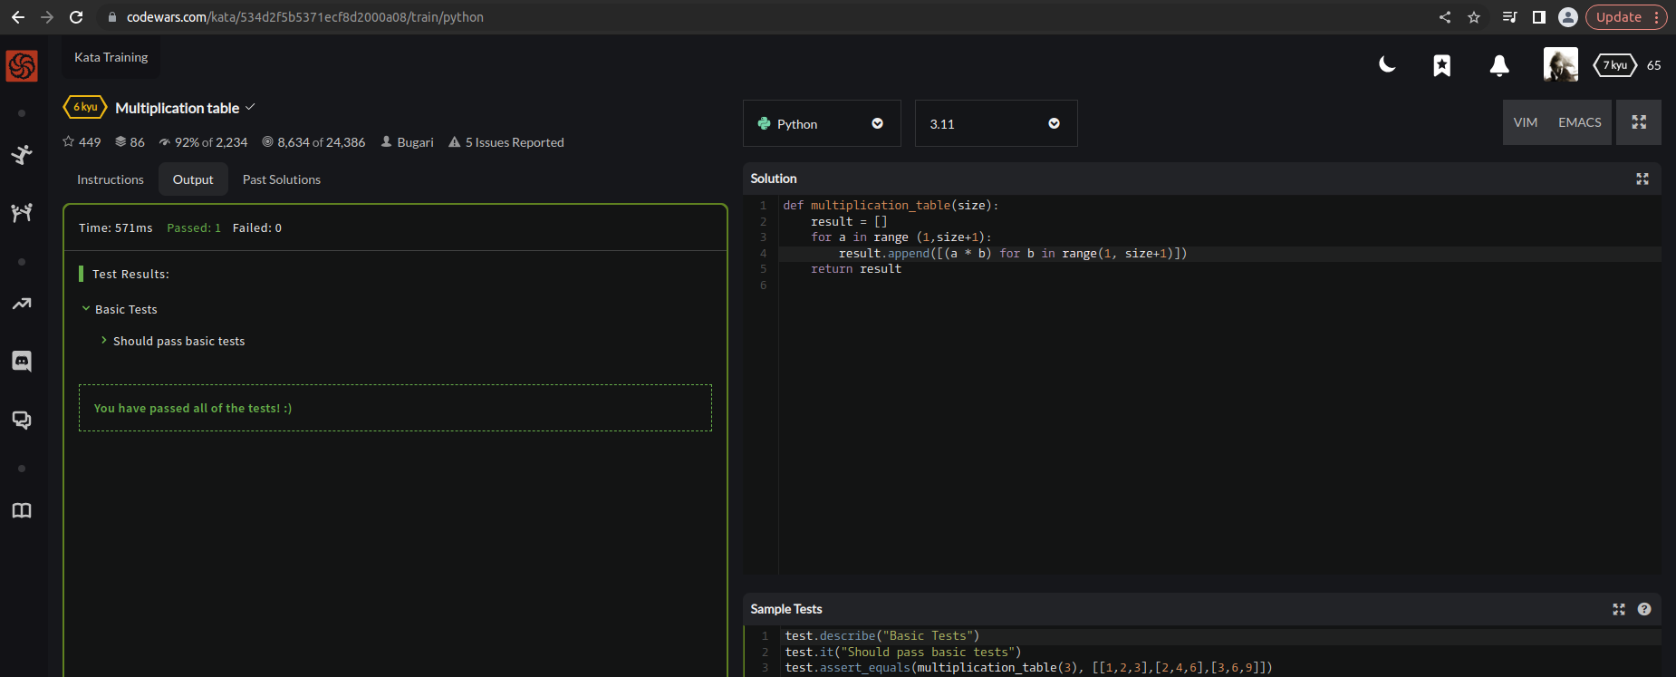

EXPLANATION:
This is a Python function that generates a multiplication table of a specified size. It takes one argument, size, which is the number of rows and columns in the table. The function starts by creating an empty list called result. It then loops over the range of numbers from 1 to size, inclusive, and for each number a, it creates a new list using a list comprehension. The list comprehension generates a list of products a * b for b in the range of numbers from 1 to size, inclusive. The resulting list of products is appended to the result list. Finally, the function returns the result list, which contains the complete multiplication table.

